CNBU108 – APPLIED OPERATING SYSTEM
LAB 4
NAGIOS CORE – MONITOR SERVER
Dao Minh Chau-24560025
Objective
- Student can install the Nagios Core with VMware
- Student can configure the Nagios Core to monitor the Linux/Windows Client
Requirement
- VMware

1. Download and install Nagios Core
- Student can download Nagios Core at: https://www.nagios.org/downloads/
- Depending on the OS, students follow the instruction of installation: https://assets.nagios.com/downloads/nagioscore/docs/nagioscore/4/en/quickstart.html
First, update and install dependencies.
sudo apt update && upgrade
sudo apt install -y autoconf gcc libc6 make wget unzip apache2 apache2-utsudo apt-get install -y openssl libssl-dev

Downloading the Source
cd /tmp
wget https://github.com/NagiosEnterprises/nagioscore/archive/nagios-4.4.14.tar.gz
tar xzf nagioscore.tar.gz

Compile
cd nagioscore-nagios-4.4.14
sudo ./configure --with-httpd-conf=/etc/apache2/sites-enabled
sudo make all

Create User And Group
This creates the nagios user and group. The www-data user is also added to the nagios group.
Sudo useradd nagios
Sudo groupadd nagcmd
Sudo usermod -a -G nagcmd nagios
sudo usermod -a -G nagcmd www-data

Install Binaries
This step installs the binary files, CGIs, and HTML files.
sudo make install

Install Service / Daemon
This installs the service or daemon files and also configures them to start on boot.

sudo make install-daemoninit

Install Command Mode
This installs and configures the external command file.

sudo make install-commandmode

Install Configuration Files
This installs the *SAMPLE* configuration files. These are required as Nagios needs some configuration files to allow it to start.

sudo make install-config

Install Apache Config Files
This installs the Apache web server configuration files and configures Apache settings.

sudo make install-webconf
sudo a2enmod rewrite
sudo a2enmod cgi

Then we need to create a nagios admin account
Create nagiosadmin User Account and specify a password, in my case that is kali.
sudo htpasswd -c /usr/local/nagios/etc/htpasswd.users nagiosadmin
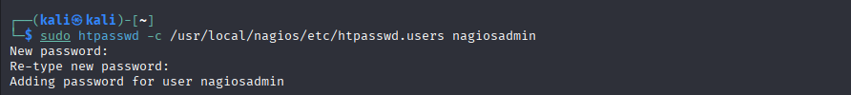

Then we need to install Nagios-plugins to use check_ncpa function to monitor NCPA agent.
wget https://github.com/nagios-plugins/nagios-plugins/archive/release-2.4.6.tar.gz
sudo tar xzf release-2.4.6.tar.gz
cd nagios-plugins-release-2.4.6
sudo ./tools/setup
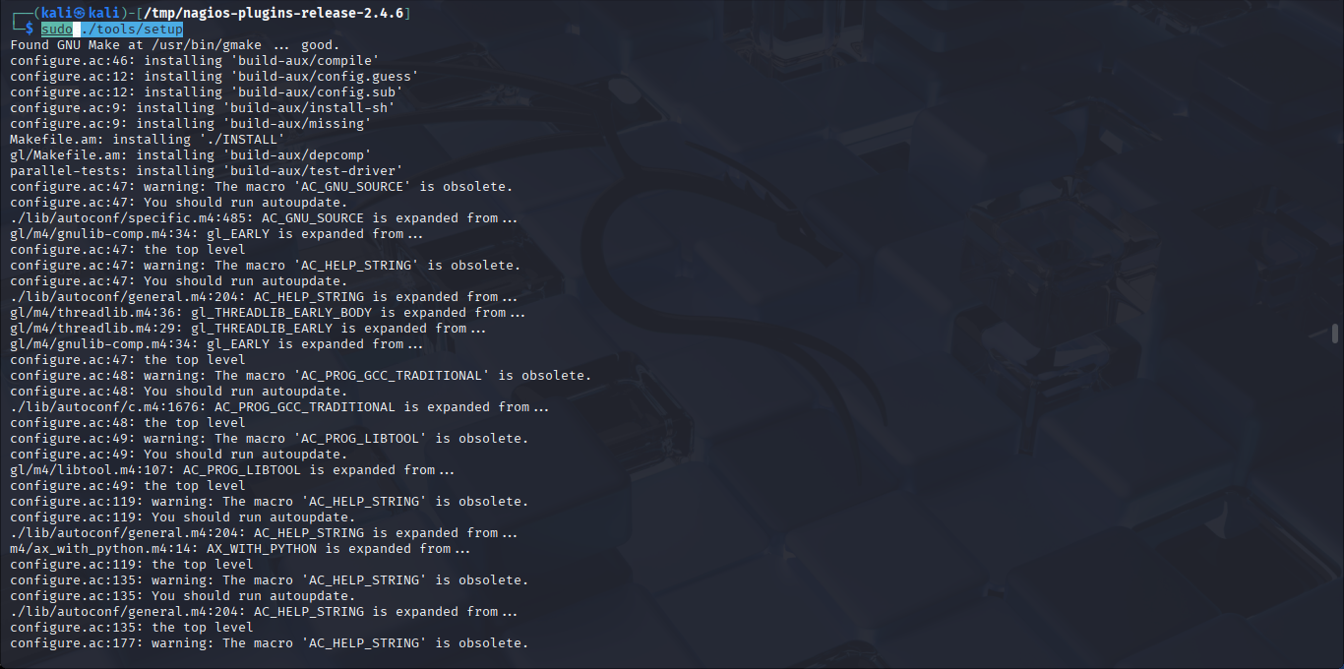

Finally start the nagios service and visit its website via my IP, 192.168.140.144/nagios and login as nagiosadmin
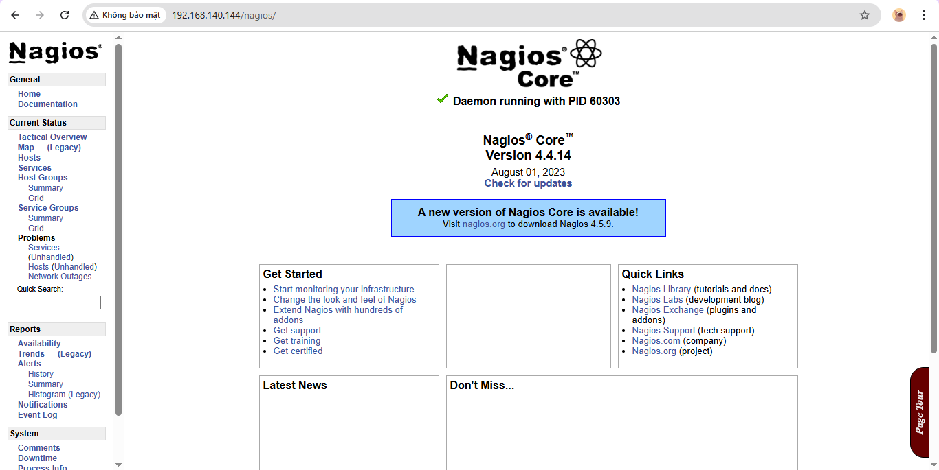

2. Install NCPA agent and configure the Nagios Core to monitor Windows client
- Students follow the instructions:

https://assets.nagios.com/downloads/nagioscore/docs/nagioscore/4/en/monitoring-windows.html
After installing NCPA, toggle to set Token to mytoken123 (or anything) and check for ipconfig to let the nagios listen to right device in later configuration.
For me the token is nagios, IP is 192.168.140.144 and use port 5693. Then go to service to check status of my device NCPA.
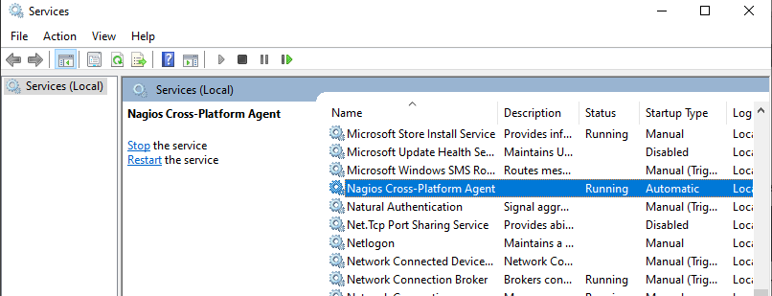

Then go to /usr/local/nagios/etc/objects/windows.cfg to define my window host and services to monitor CPU and Memory usage:
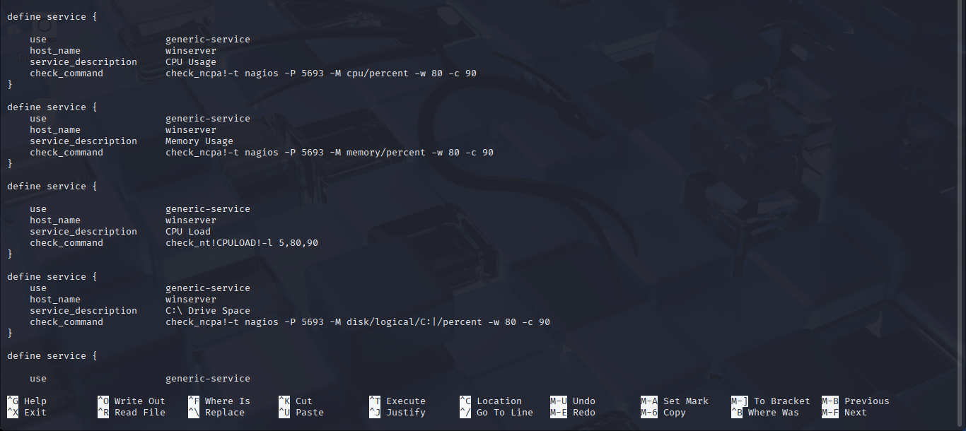
After finish configurating, use sudo /usr/local/nagios/bin/nagios -v /usr/local/nagios/etc/nagios.cfg to check errors if existed and then restart the nagios.
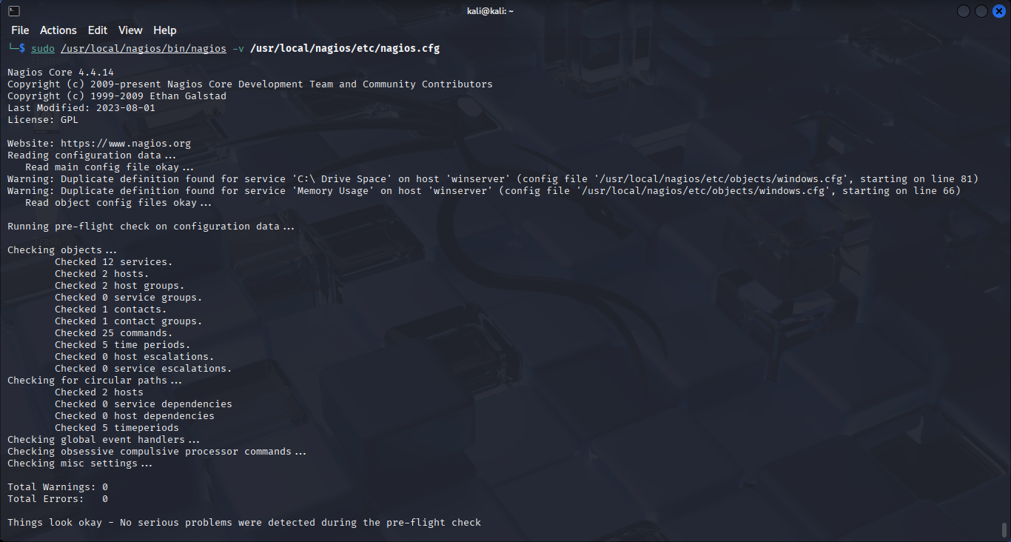

3. Inspect the monitoring view
- Students capture the monitor view and give short description on the dashboard.
The localhost is the one VM running nagios and the web, and the win client is my real device that run NCPA agent.

4. Create an event
- Base on the configuration information in steps 2. Make the CPU load or memory higher, so that Nagios can raise an alarm on the event of high CPU load or high memory.
I make a command to max out CPU usage in PowerShell and check in Nagios
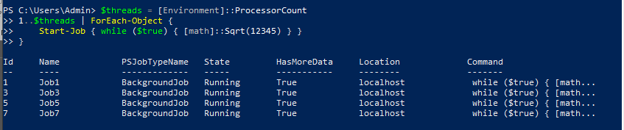

Then I go to Nagios and check.
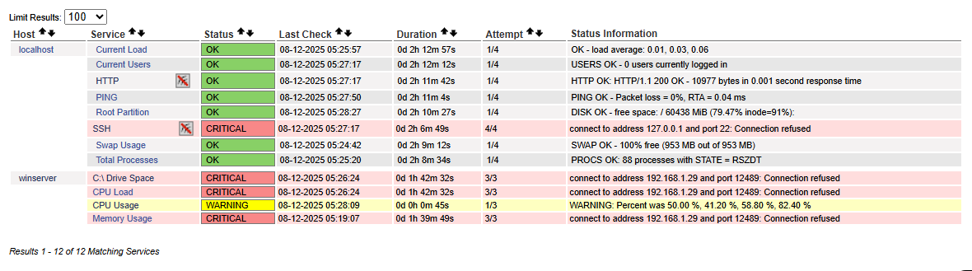

And after the traffic is released
